

**Course Information**

Course Title: Digital Image Processing

Section: 1

Course Instructor: Dr. Ahmed Wasif Reza

Associate Professor

Department of Computer Science & Engineering

**Lab-03**

**Student’s Information**

**Name:** Mujahidul Islam

**ID:** 2019-2-60-072

**Department:** Computer Science & Engineering

**Date of Submission: 3 November 2022**

**Question 1**

Adjust the histogram of the following image to match the reference image using histogram matching. Show the histogram of original, reference, and output images.

Code:

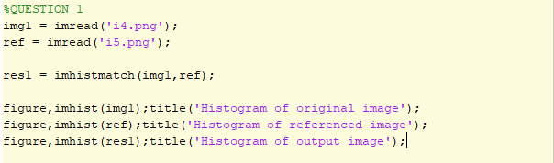

Output:

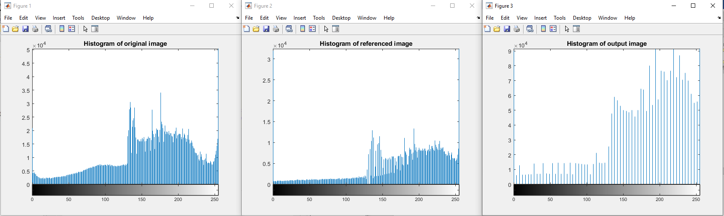

Fig: Original image Fig: Reference Image Fig: Output Image

**Question 2**

Change the contrast of the image using histogram equalization. Show the histogram of both input and output images.

Code:

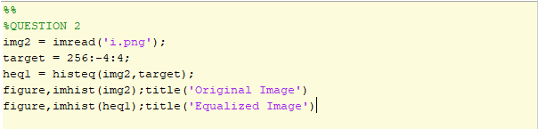

Output:

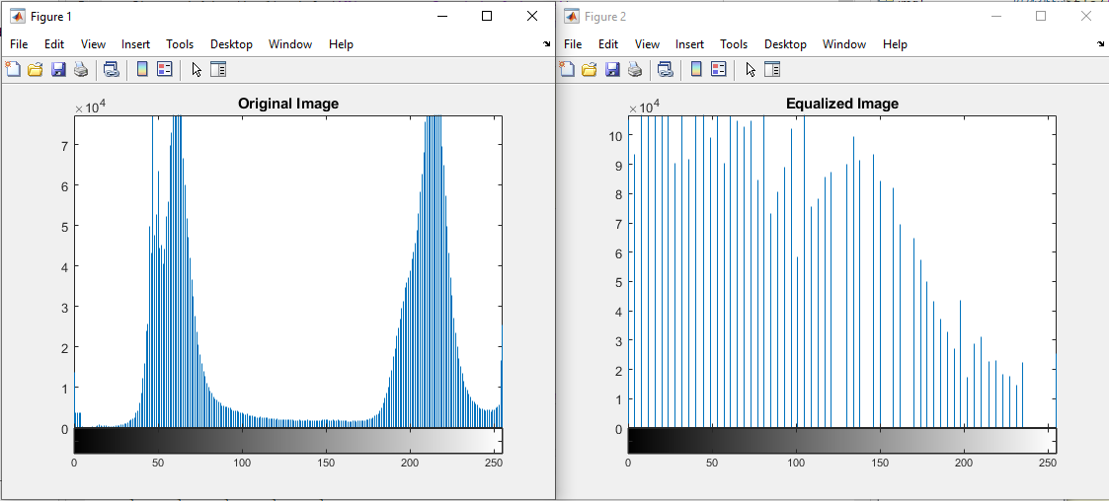

Fig: Input Image Fig: Output Image

**Question 3**

Apply salt and pepper noise to the following image and remove the noise using min and max filtering technique. Show input and output side by side.

Code:

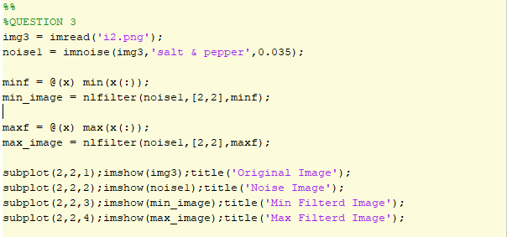

Output:

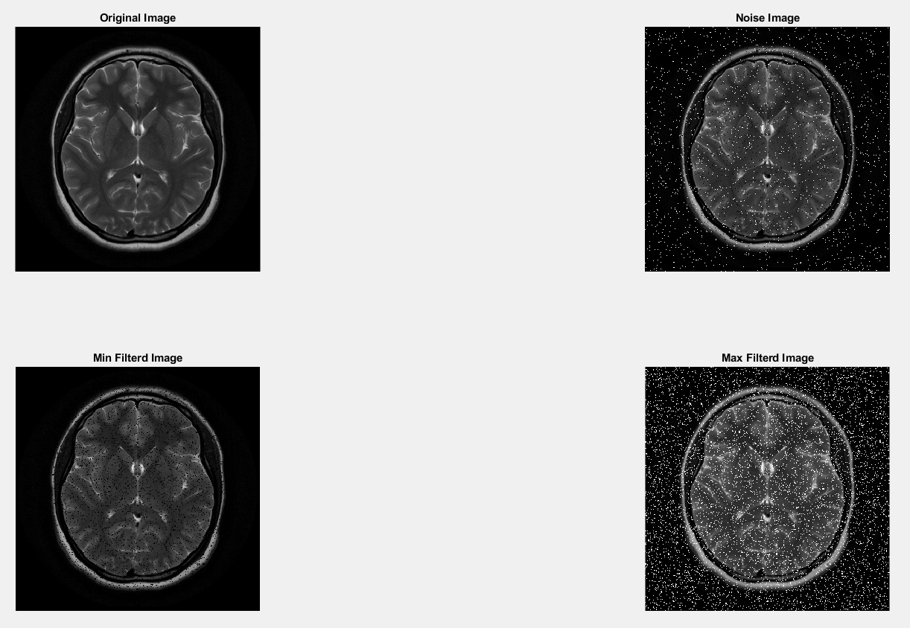

**Question 4**

Apply Gaussian noise to the following image and remove the noise using Gaussian filtering. Show input and output side by side.

Code:

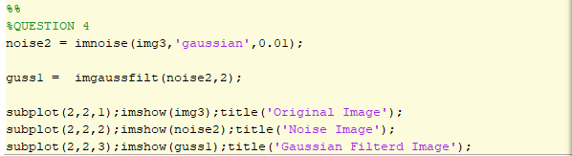

Output:

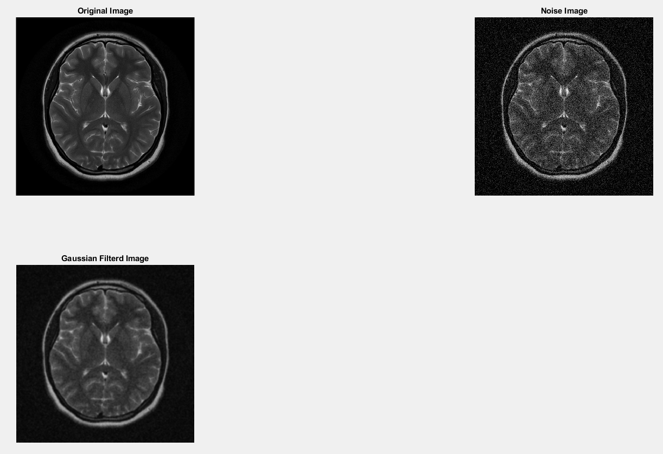

**Question 5**

Apply any noise to the following image and restore it using:

1. Box filtering
2. Average filtering
3. Median filtering

Show input and output side by side. Also show the comparison between the 3 techniques. Mention which method works better than others.

Code:

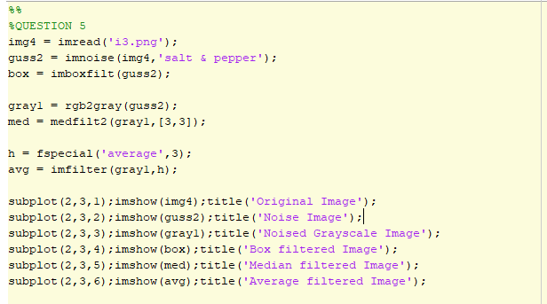

Output:

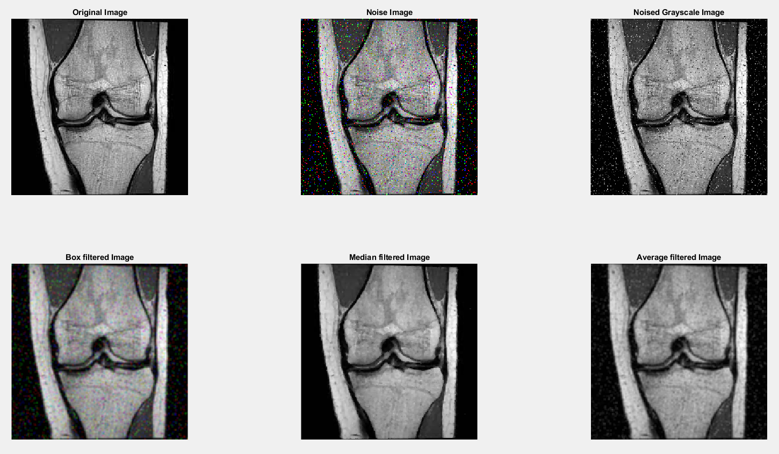

Comparison among three filter:

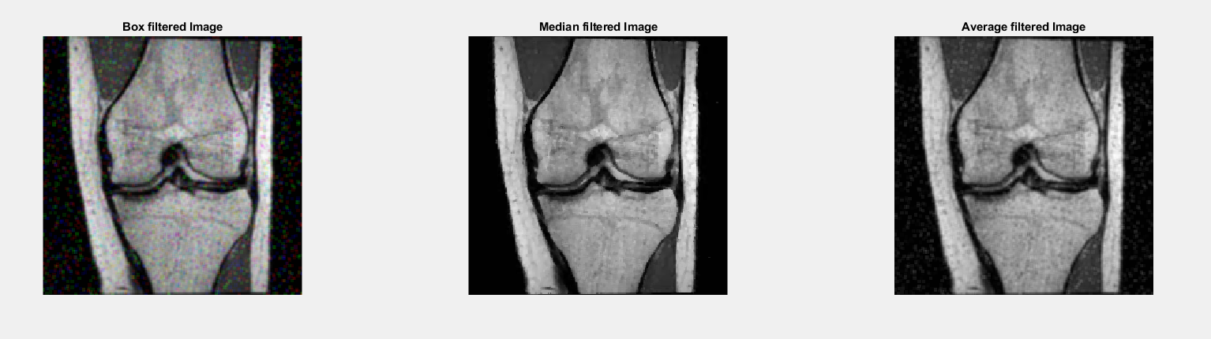

Fig: Box filtered Image Fig: Median filter Image Fig: Average filter image

Among the three filters median filter image reduced the noise most as well as it is sharper than the other filtered image. So median filter image is works better to reduce noise.